**Module 4 Predictive Analytics**

**Author’s Name:** Shivani Sharma

**Course Number:** ALY6020

**Course Title:** Predictive Analytics

**Academic Term:** Fall 2019 CPS Analytics

**Instructor’s Name:** Marco Montes de Oca

**Assignment Completion Date:** 10-13-2020



**Introduction**

This week’s assignment looks very interesting which is based on Tic Tac Toe game. Before starting with the game, I would like to give a brief introduction about neural networks. We can train neural network via multiple methods. There is one powerful library “Keras” with the help of which we can build and train a neural network for performing automated tasks like playing a game.

A “tic tac toe” is a game of “0”’s and “X”’s when we have 3 consecutive “0”’s and “X”’s either in straight line or diagonally. As per the problem statement we have to train a model for taking the inputs and teach the algorithm to play on its own.

**Analysis**

Here is the logic for the same:

First importing the required libraries:

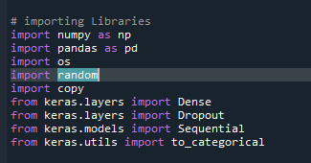

Here I am training the model using sequential model. I am using keras library for building neural network.:

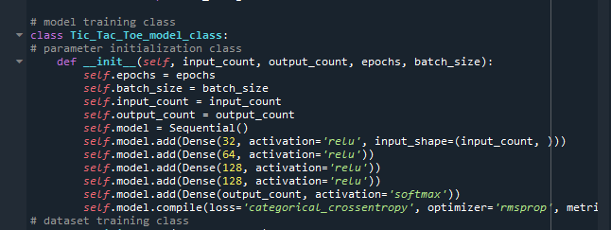

Then I have defined a training set and reshaped the parameters. Splitted the parameters into train and test for features and labels. Then fitted the model and predicted values for the output.

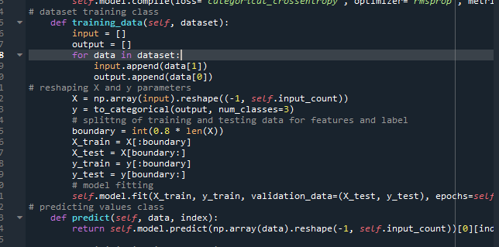

Now starting with the logic of game. Here are the parameters which I am going to use in the game logic:

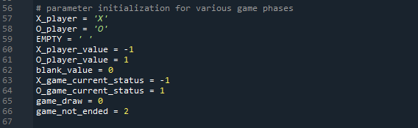

Now initializing the parameters and initial values of the board. Then displaying the values of the board:

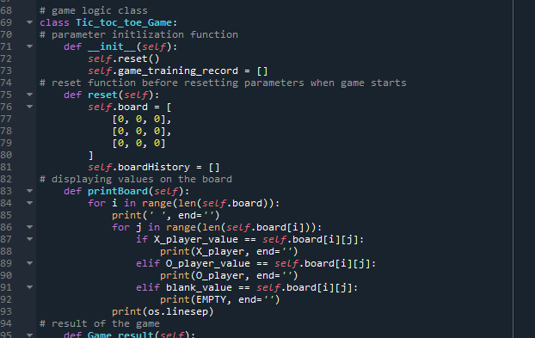

Now we have to calculate the result of the based on the logic of values of input for rows and columns. Also, here I am calculating the values for diagonal lines. From this function we are also calculating the value if there is a draw.

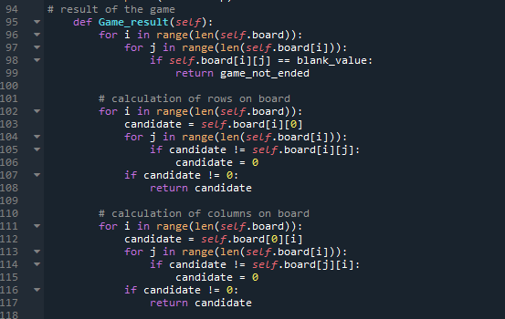

Now we have to find out that how many turns are left for the player and when to make a move in the game and here is the logic for the same:

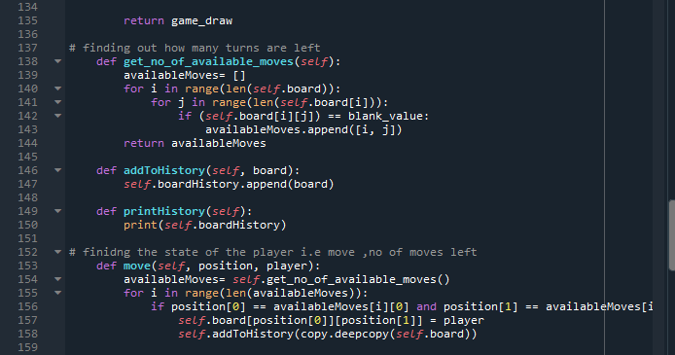

Now I am training the model i.e neural network and here is the logic for the same:

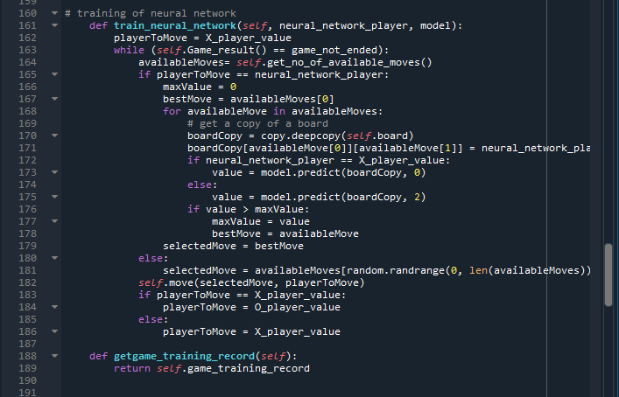

Now we have to automate the training process by allowing the logic to find out which player needs to move and when to move i.e on which move.

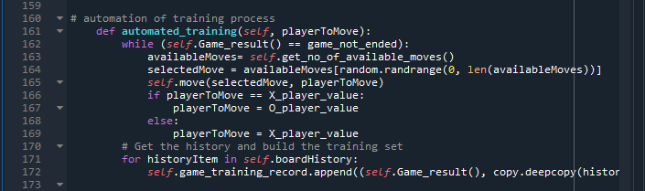

Along with the neural network automation we have to automate the game logic as well for player “0” and “X” :

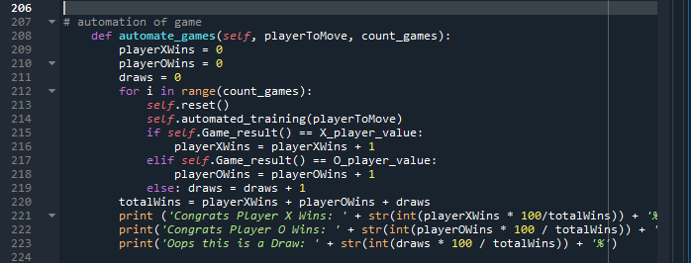

Now finally here is the automation of neural network for finding the winning and loosing logic by neural network:

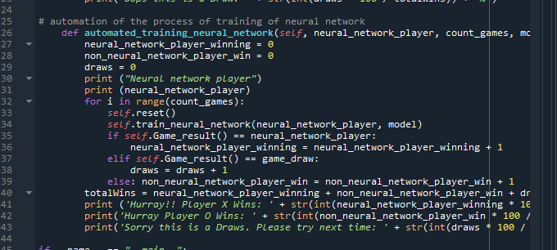

Invoking the above created functions via main method:

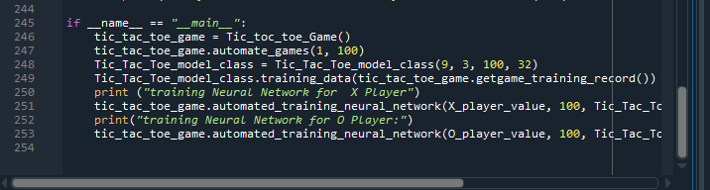

**Conclusion**

Here is the explanation of the output of the model:

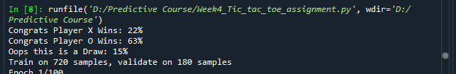

The above output is coming from the model before training it i.e just feeding the input and getting output. I have sample size of 900 and splitted into train and validation sets. I have trained the model for 100 epochs and here is the output for the same:

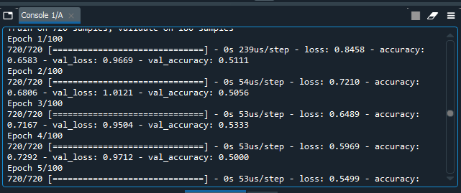

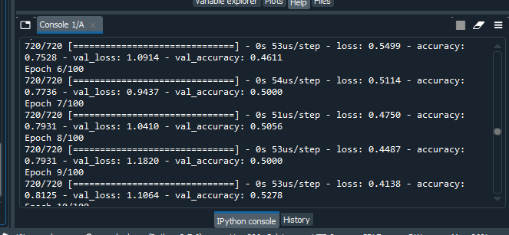

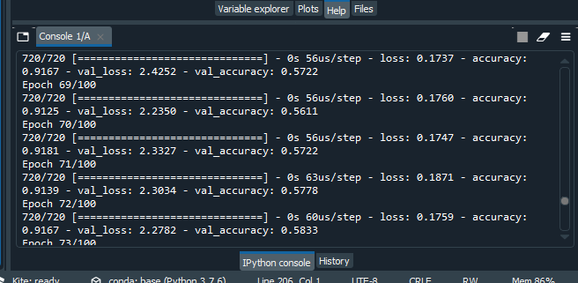

I als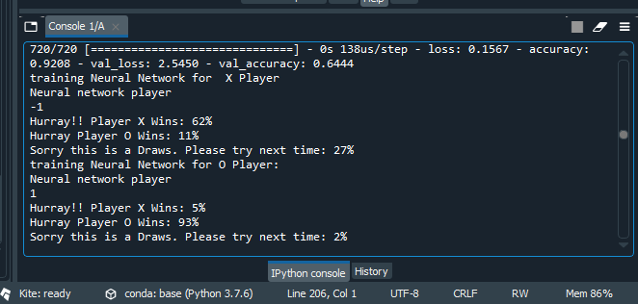

From the above outputs we can conclude that the model is training the neural network with fair game for both players i.e 0 and X and providing fair chances of winning to both the players. From the results we can see that for both the players network is showing a clear difference in the winning probabilities.

# References

1. <https://www.youtube.com/watch?v=tf3ezjeTpfI&list=PLQVvvaa0QuDeAams7fkdcwOGBpGdHpXln&index=3>
2. Borcan, M. (2020, April 09). Machine Learning Project: Neural Network Learns To Play Tic-Tac-Toe. Retrieved October 13, 2020, from https://programmerbackpack.com/python-neural-network-tutorial/
3. Keras Tutorial: Recognizing Tic-Tac-Toe Winners with Neural Networks. (n.d.). Retrieved October 11, 2020, from <https://www.kdnuggets.com/2017/09/neural-networks-tic-tac-toe-keras.html>
4. <https://medium.com/@carsten.friedrich/part-2-the-min-max-algorithm-ae1489509660>
5. Borcan, M. (2020, April 09). Machine Learning Project: Neural Network Learns To Play Tic-Tac-Toe. Retrieved October 11, 2020, from https://programmerbackpack.com/python-neural-network-tutorial/
6. <https://medium.com/byte-tales/the-classic-tic-tac-toe-game-in-python-3-1427c68b8874>
7. Jaspers, T. (2018, January 15). Neural Network and Machine Learning in a simple game. Retrieved October 11, 2020, from https://blog.codecentric.de/en/2018/01/gamma-tictactoe-neural-network-machine-learning-simple-game/
8. Khurana, S. (2019, May 28). Building a neural network that learns to play a game - Part 1. Retrieved October 11, 2020, from https://medium.com/@sanilkhurana7/building-a-neural-network-that-learns-to-play-a-game-part-1-e408ae7106d0
9. Luo, J. (2019, September 11). An Exploration of Neural Networks Playing Video Games. Retrieved October 11, 2020, from https://towardsdatascience.com/an-exploration-of-neural-networks-playing-video-games-3910dcee8e4a
10. Jaspers, T. (2018, January 15). Neural Network and Machine Learning in a simple game. Retrieved October 11, 2020, from https://blog.codecentric.de/en/2018/01/gamma-tictactoe-neural-network-machine-learning-simple-game/
11. Ashely, & Vinita. (2019, July 19). How can I create an AI for tic tac toe in Python using ANN and genetic algorithm? Retrieved October 11, 2020, from https://intellipaat.com/community/13326/how-can-i-create-an-ai-for-tic-tac-toe-in-python-using-ann-and-genetic-algorithm